Member Name | Member Roll # | Primary Responsibility
Shehryar Munir | 20L-1302 | · Patients use cases  · Analysis Class diagram
Fatima Siddiqui | 20L-1213 | · Patients use cases  · Integration of use cases
Irtaza Zulfiqar | 20L-1290 | · Analysis Class diagram  · Lab Technician use cases
Muhammad Abdullah | 20L-1261 | · Use case diagram  · Pharmacists use cases
Samreen Abbas | 20L-1292 | · Doctors use cases  · Admin use cases
Rabia Shakil | 20L-1319 | · Doctors use cases  · Admin use cases
E-Heal
Phase # 1
Team # 4

Team # 4

Table of Contents

1. Use case diagram …………………………………………………………………………...1
2. Analysis class diagram ……………………………………………………………………..2
3. Use cases E-Heal ……………………………………………………………………………3

Use case diagram

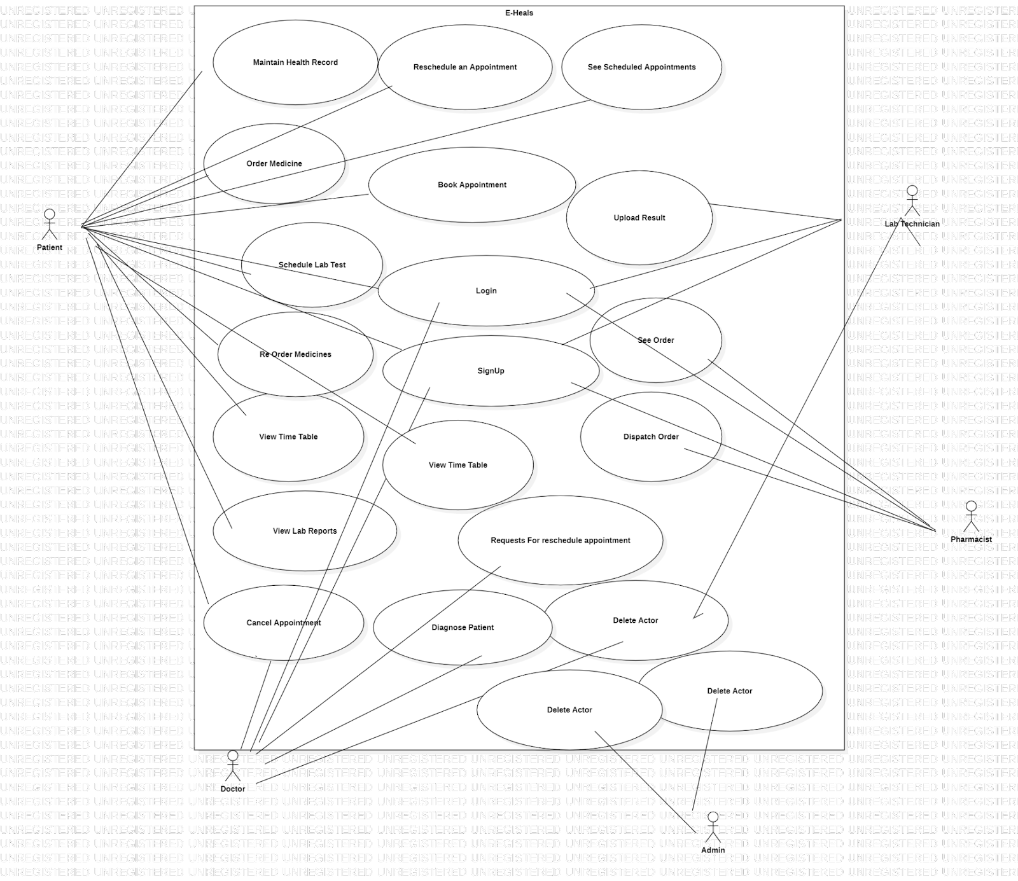

Analysis class diagram
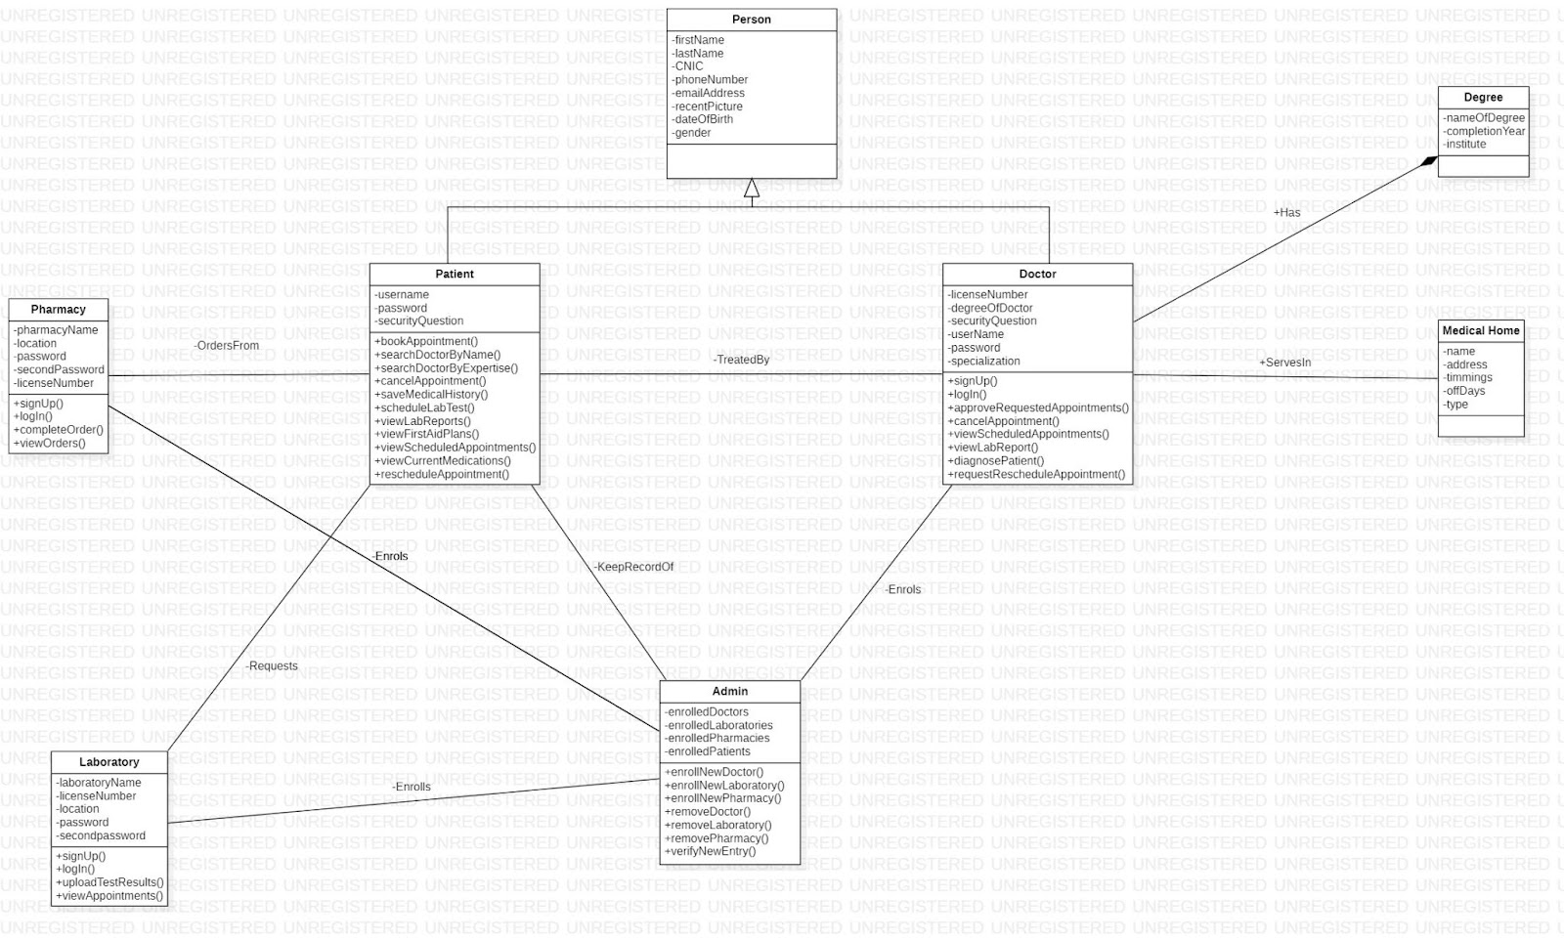

Use cases E-Heal

This document contains the use cases of every user of the application E-Heal.
- These Use case would be performed by every single user of application.
Identifier |  |  | UC-1
Name |  |  | Sign Up
Summary |  |  | Actors will sign up for the usage of application
Priority |  |  | High
Actors |  |  | Patient, Doctor, Lab Technician, Pharmacist
Pre-condition(s) |  |  | Actor should have required information for the sign up
Post-condition(s) |  |  | Actor signed up for E-Heal
Typical Course of Action
S# |  | Actor Action |  |  | System Response
1 |  | Selects “Sign Up”
2 |  |  |  |  | Prompt for the required fields
3 |  | Enters the information of required fields
4 |  |  |  |  | Verifies information
5 |  |  |  |  | Display “Information Verified
6 |  |  |  |  | Displays “Successful Sign up”
Alternate Course of Action (Missing Required Field)
 | Actor Action |  |  |  |  | System Response
3 |  |  |  |  |  | Prompt for required fields
 | Go to Step 3
Alternate Course of Action (Information not found)
Actor Action |  |  |  | System Response
5 |  |  |  | Displays “Information not found”
 | Go to Step 3

Identifier |  |  | UC-2
Name |  |  | Login
Summary |  |  | Actors will login to their account
Priority |  |  | High
Actors |  |  | Patient, Doctor, Lab Technician, Pharmacist
Pre-condition(s) |  |  | Actor should have required information for the login
Post-condition(s) |  |  | Actor logged in E-Heal
Typical Course of Action
S# |  | Actor Action |  |  | System Response
1 |  | Selects “Login”
2 |  |  |  |  | Prompt for the required fields
3 |  | Enters the information of required fields
4 |  |  |  |  | Verifies information
5 |  |  |  |  | Logs in the actor
Alternate Course of Action (Enters wrong information)
 | Actor Action |  |  |  |  | System Response
3 |  |  |  |  |  | Deny information
 | Go to step 2
Alternate Course of Action (Password forgotten)
Actor Action |  |  |  | System Response
3 | Selects “Forget password”
4 |  |  |  | Prompt for security question / second password
5 | Enters security question / second password
6 |  |  |  | Verifies information
7 |  |  |  | Prompt for new password
8 | Enters new password
9 | Saves new password

- Patient: These all use cases are triggered after the selection of relevant options from home page.

Identifier |  | UC-3
Name |  | Book Appointment
Summary |  | Patient books appointment by searching required doctor
Priority |  | High
Actors |  | Patient
Pre-condition(s) |  | Patient must be logged in
Post-condition(s) |  | System records appointment
Typical Course of Action
S# | Actor Action |  | System Response
1 | Searches doctor by name/by specialization
2 |  |  | Displays list of doctors
3 | Selects doctor of his choice
4 |  |  | Displays information of the chosen doctor
5 | Selects time slot for appointment
6 | Applies for appointment
7 |  |  | Displays message “Appointment requested successfully”
8 | Waiting for appointment approval response from doctor
9 |  |  | Gets response from doctor
10 |  |  | Displays message “Appointment Approved”
Alternate Course of Action (Request Rejected)
S# | Actor Action |  | System Response
11 |  |  | Displays message” Appointment Rejected”
12 |  |  | Displays reason of rejection provided by doctor
Go to step 5

Identifier |  | UC-4
Name |  | Cancel Appointment
Summary |  | Patient can cancel the appointment which will be reschedule afterwards
Priority |  | High
Actors |  | Patient
Pre-condition(s) |  | - Patient must be logged in  - Patient must have booked an appointment
Post-condition(s) |  | Appointment has been cancelled
Typical Course of Action
S# | Actor Action |  | System Response
1 | Selects “Cancel Appointment”
2 |  |  | Displays confirmation message” Appointment has been canceled successfully”
3 |  |  | Updates Scheduled appointments for both the doctor and the patient

Identifier |  | UC-5
Name |  | Maintain Health Record
Summary |  | User enters his/her medical history and system saves it
Priority |  | Medium
Actors |  | Patient
Pre-condition(s) |  | - Patient must be logged in  - User must have uploaded medical history
Post-condition(s) |  | Medical records are saved.
Typical Course of Action
S# | Actor Action |  | System Response
1 | Selects “Enter Medical Record”
2 |  |  | Displays the form for medical history
3 | Fills the required medical information
4 | Selects “Save”
5 |  |  | Saves the entire record in patients’ medical history

Identifier |  | UC-6
Name |  | Order Medicines
Summary |  | Users can order medicines online from a list of pharmacies available and get the medicines prescribed by a doctor at home.
Priority |  | Medium
Actors |  | Patient
Pre-condition(s) |  | - Patient must be logged in  - Patient must have a prescription given by the doctor.
Post-condition(s) |  | Medicines have been ordered online.
Typical Course of Action
S# | Actor Action |  | System Response
1 | Select the “Order Medicines Online”
2 |  |  | Displays list of available pharmacies
3 | Chooses a pharmacy
4 | Selects prescription(s)
5 |  |  | Asks for a quantity of medicines to be delivered.
6 | Specifies quantity of medicines
7 | Select “Order Medicine”
8 |  |  | Sends Prescription to specified pharmacy

Identifier |  | UC-7
Name |  | Schedule Lab Test
Summary |  | Patients can schedule lab tests and can ask for home services if possible.
Priority |  | High
Actors |  | Patient
Pre-condition(s) |  | - Patient must be logged in  - Patient must have lab tests prescribed by doctor
Post-condition(s) |  | Lab test has been requested successfully.
Typical Course of Action
S# | Actor Action |  | System Response
1 | Select the “Book Lab Test”
2 |  |  | Displays list of available laboratories
3 | Chooses a laboratory
4 | Shares lab test prescription
5 |  |  | Displays available time slots for lab tests.
6 |  |  | Asks for available date and time for home sample collection
7 | Selects suitable date and time
8 |  |  | Displays confirmation message “Lab test has been requested successfully”.
9 | Wait for the response
10 |  |  | Displays the approval message once approved
 | Alternate Course of Action (Disapproved Appointment)
10 |  |  | Displays the disapproval message along with reason

Identifier |  | UC-8
Name |  | View Lab Reports
Summary |  | Patient can view his/her lab reports.
Priority |  | Medium
Actors |  | Patient
Pre-condition(s) |  | - Patient must be logged in  - Patient has taken lab services.
Post-condition(s) |  | Results of lab tests can be viewed.
Typical Course of Action
S# | Actor Action |  | System Response
1 | Selects the “View Lab Test Report”
2 |  |  | Displays results of lab tests.
Alternate Course of Action (Reports not uploaded)
S# | Actor Action |  | System Response
2 |  |  | Displays message “Reports have not been uploaded yet”

Identifier |  | UC-9
Name |  | First Aid
Summary |  | User can look up for first aid ideas for desired problem
Priority |  | Medium
Actors |  | Patient
Pre-condition(s) |  | Patient must have logged in.
Post-condition(s) |  | Required solution found
Typical Course of Action
S# | Actor Action |  | System Response
1 | Selects the “First Aid”
2 |  |  | Display list of incidents for which first aid is needed.
3 | Selects incident for which measures are needed
4 |  |  | Displays all measures that can be taken

Identifier |  | UC-10
Name |  | See Scheduled Appointments
Summary |  | User can view his scheduled appointments
Priority |  | Low
Actors |  | Patient
Pre-condition(s) |  | - Patient must be logged in  - Patient must have booked appointments.
Post-condition(s) |  | Schedule of appointment is visible
Typical Course of Action
S# | Actor Action |  | System Response
1 | Selects the “See Scheduled Appointments”
2 |  |  | Display scheduled appointments
Alternate Course of Action (No Appointments booked)
S# | Actor Action |  | System Response
2 |  |  | Displays message” No Appointment is scheduled”.

Identifier |  | UC-11
Name |  | View Timetable
Summary |  | User can view his timetable for current medications.
Priority |  | High
Actors |  | Patient
Pre-condition(s) |  | - Patient must be logged in  - Patient must have a prescription from doctor
Post-condition(s) |  | Timetable of medicines is visible
Typical Course of Action
S# | Actor Action |  | System Response
1 | Selects the “View Timetable”
2 |  |  | Displays graphical representation of currently prescribed medicines with checkboxes.
3 | Fills checkbox after taking medicines
4 |  |  | Save changes.
Alternate Course of Action (No current medications)
S# | Actor Action |  | System Response
2 |  |  | Displays message” No Medicines have been prescribed by doctor”.

Identifier |  | UC-12
Name |  | Reorder Unavailable Medicines
Summary |  | Users can Reorder medicines online from a list of pharmacies available if desired medicines were not available from one pharmacy.
Priority |  | medium
Actors |  | Patient
Pre-condition(s) |  | - Patient must be logged in  - There should be some medicines unavailable in previous ordered medicine prescription.
Post-condition(s) |  | Medicines have been ordered online.
Typical Course of Action
S# | Actor Action |  | System Response
1 | Select the “Reorder Medicines Online” option from the homepage.
Include UC-6 here

Identifier |  | UC-13
Name |  | Reschedule appointment
Summary |  | Patient can reschedule appointment with doctor
Priority |  | medium
Actors |  | Patient
Pre-condition(s) |  | - Patient must be logged in  - Doctor must have requested for rescheduling appointment
Post-condition(s) |  | Appointment rescheduled
Typical Course of Action
S# | Actor Action |  | System Response
1 | Selects “Reschedule Appointment”
2 |  |  | Ask to fill the date and time slot
3 | Fills the date and time slot for appointment
4 |  |  | Sends message to the doctor of new schedule of appointment

B ) Doctor: These all use cases are triggered after the selection of relevant options by actor from home page.

Identifier |  | UC-14
Name |  | Approve Requested Appointments
Summary |  | Doctor will approve the appointments requested by patients.
Priority |  | High
Actors |  | Doctor
Pre-condition(s) |  | - Doctor must be logged in  - Patient must have requested for the appointment.
Post-condition(s) |  | Patient will get the message of approval or disapproval of appointment request.
Typical Course of Action
S# | Actor Action |  | System Response
1 | Selects “View Appointments”
2 |  |  | Display list of requested appointments
3 | Go through the medical condition of the patient
4 | Approves the appointment
5 |  |  | Sends the appointment approval message to the patient.
Alternate Course of Action (Appointment Request Rejected)
S# | Actor Action |  | System Response
4 | Disapproves the appointment
5 | Enters the reason for disapproval
6 |  |  | Sends the appointment disapproval message to the patient
7 |  |  | Displays reason for disapproval

Identifier | UC-15
Name | View Lab Reports
Summary | Doctor will be able to view the reports of the Lab Tests assigned to a specific patient
Priority | Medium
Actors | Doctor
Pre-condition(s) | - Doctor must be logged in  - Lab reports are available
Post-condition(s) | Sends comments to the patient
Typical Course of Action
S# | Actor Action | System Response
1 | Selects “View Lab Reports”
2 |  | Lab Reports are displayed
3 | Open the report of a (any)patient
4 |  | Displays the report of patient
5 | Examines the report
6 | Leave Comment for patient
7 |  | Sends comment to the patient
Alternate Course of Action (Does Not leave any comment)
S# | Actor Action | System Response
6 | Didn't leave any comment to patient
7 |  | Will not send any comment to the patient

Identifier |  | UC-16
Name |  | Diagnose the patient
Summary |  | Doctor will diagnose the disease and fill the recommendations
Priority |  | High
Actors |  | Doctor
Pre-condition(s) |  | - Doctor must be logged in  - Doctor should have examined the patient physical on clinic / hospital
Post-condition(s) |  | Patients will have the record of his disease and recommendations
Typical Course of Action
S# | Actor Action |  | System Response
1 | Examines patient
2 | Selects “Diagnose”
3 |  |  | Displays diagnosis form
4 | Fills diagnosis form
5 | Saves the form
6 |  |  | Displays success message
Alternate Course of Action (Unable to save diagnosis form)
S# | Actor Action |  | System Response
4 | Leaves any of required field empty
5 |  |  | Displays the error message

Identifier |  | UC-17
Name |  | Cancel the appointment
Summary |  | Doctor will cancel the appointment
Priority |  | High
Actors |  | Doctor
Pre-condition(s) |  | - Doctor must be logged in  - Patient must have scheduled appointment with doctor
Post-condition(s) |  | Patients’ appointment with doctor is cancelled
Typical Course of Action
S# | Actor Action |  | System Response
1 | Selects “Cancel Appointment”
2 |  |  | Prompts for valid reason
3 | Enters the reason for the cancellation
4 |  |  | Sends appointment cancellation message to the patient

Identifier | UC-18
Name | Requests for reschedule appointment
Summary | Doctor will be able to reschedule upcoming appointment(s) with a patient to another time along with giving a reason
Priority | Medium
Actors | Doctor
Pre-condition(s) | - Doctor must be logged in  - Doctor must have cancelled appointment  - Patient must have requested for appointment
Post-condition(s) | Patient is requested to reschedule appointment
Typical Course of Action
S# | Actor Action | System Response
1 | Selects “Reschedule Appointment
2 | Leave comment to patient
3 |  | Requests patient for reschedule
4 |  | Display reason for rescheduling request
Include UC-13

C) Pharmacist: These all use cases are triggered after the selection of relevant options by actor from home page.

Identifier |  | UC-19
Name |  | See Order
Summary |  | The pharmacist will view the list of arrived orders of medicines.
Priority |  | High
Actors |  | Pharmacist
Pre-condition(s) |  | - Pharmacist must have logged in  - Patient must have placed the order for medicines.
Post-condition(s) |  | Checklist of available medicines will be maintained.
Typical Course of Action
S# | Actor Action |  | System Response
1 | Select “See Orders” option.
2 |  |  | Displays list of newly placed orders of medicines.
3 | View prescription of any patient
4 |  |  | Displays prescription of selected patient.
5 | Add available medicines to cart
6 | Mark the available medicines
7 |  |  | Save the record
8 |  |  | Generates Bill
9 |  |  | Informs patient about available medicines
Alternate Course of Action (Medicines unavailble)
S# | Actor Action |  | System Response
9 |  |  | Informs patient about unavailable medicines

Identifier |  | UC-20
Name |  | Dispatch Order
Summary |  | The pharmacist will complete the order of medicines and dispatch the order and system will inform patient about delivery
Priority |  | High
Actors |  | Pharmacist
Pre-condition(s) |  | - Pharmacist must be logged in  - Order must be completed and ready
Post-condition(s) |  | Order is dispatched.
Typical Course of Action
S# | Actor Action |  | System Response
1 | Selects “Dispatch Order” option.
2 |  |  | Sends success message about dispatched order to patient.

D ) Lab Technician: These all use cases are triggered after the selection of relevant options by actor from home page
Identifier |  | UC-21
Name |  | Approve Appointment
Summary |  | The Lab Technician approve the lab test appointment.
Priority |  | High
Actors |  | Lab Technician
Pre-condition(s) |  | - Lab Technician must be logged in  - Patient must have applied for lab test appointment.
Post-condition(s) |  | Lab test appointment will be approved / disapproved.
Typical Course of Action
S# | Actor Action |  | System Response
1 | Selects “Approve Appointment” option.
2 |  |  | Displays list of Appointments.
3 | Clicks appointment.
4 |  |  | Displays details of selected lab test appointment.
5 | Approves the selected appointment if feasible
6 |  |  | Sends approval message to the patient
Alternate Course of Action (Disapproval of appointment)
S# | Actor Action |  | System Response
5 | Disapprove the selected appointment
6 | Enters the reason for disapproval
7 |  |  | Sends the disapproval message to the patient along with reason

Identifier |  | UC-22
Name |  | Upload Results
Summary |  | The lab technicians will upload the results of lab reports.
Priority |  | Medium
Actors |  | Lab Technician
Pre-condition(s) |  | - Lab Technician must be logged in  - Lab test must be done
Post-condition(s) |  | Results of Lab reports will be uploaded.
Typical Course of Action
S# | Actor Action |  | System Response
1 | Selects “Upload Lab Report” option.
2 |  |  | Displays list of patients
3 | Selects patient
4 |  |  | Prompt for lab report
5 | Upload the lab report
6 |  |  | Sends confirmation message to the patient

E ) Admin: These all use cases are triggered after the selection of relevant options by actor from home page

Identifier |  | UC– 23
Name |  | Enrol Actors
Summary |  | Admin can enrol new doctors, lab technician, pharmacist manually
Priority |  | High
Actors |  | Admin
Pre-condition(s) |  | Actor to be enrolled must be available physical along with his degrees for verification
Post-condition(s) |  | Actors are enrolled in application
Typical Course of Action
S# | Actor Action |  | System Response
1 | Selects “Enrol User”
2 |  |  | Prompt for User’s category
3 | Selects user category
4 |  |  | Prompt for user’s information
5 | Enters required information
6 |  |  | Displays message” Enrolled Successfully”

Identifier |  | UC– 24
Name |  | Delete Users
Summary |  | Admin can delete doctors, lab technician, pharmacist
Priority |  | High
Actors |  | Admin
Pre-condition(s) |  | Admin must have enrolled users.
Post-condition(s) |  | Users are deleted and records are updated for against respective users.
Typical Course of Action
S# | Actor Action |  | System Response
1 | Selects “Delete User”
2 |  |  | Ask for User’s category
3 | Selects user category
4 |  |  | Prompt for license number
5 |  |  | Displays the user
6 | Deletes the user
7 |  |  | Display message “Deleted Successfully”

